Use the below data find the relationship between age (in months) and height (Average height in cm)

* + age=16:27
  + height=c(61.1,61.2,61.8,62.8,63.5,76.1,77,78.1,78.2,78.8,79.7,79.9)

1. Check that age and height have the same number of elements

**Ans**

> age=16:27

> height=c(61.1,61.2,61.8,62.8,63.5,76.1,77,78.1,78.2,78.8,79.7,79.9)

> a=length(age)

> a

[1] 12

> b=length(height)

> b

[1] 12

> if(a==b){print("the length is same")} else {print("length is not same")}

[1] "the length is same"

1. Create a scatterplot to determine the relationship between age and height

**Ans**

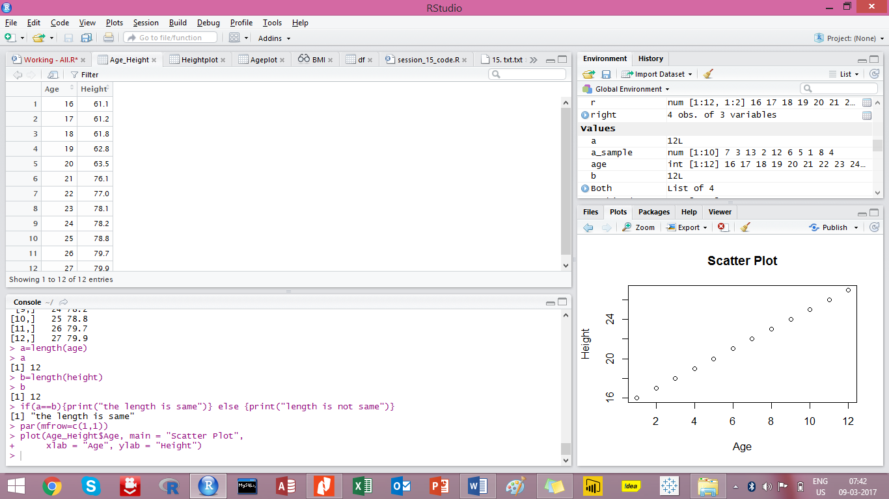

Script for making the scatter plot

Table capturing Age and Height

1. Create a "linear model" to fits the data above

**Ans**

> get=lm(height~age, data = Age_Height)

> summary(get)

Call:

lm(formula = height ~ age, data = Age_Height)

Residuals:

Min 1Q Median 3Q Max

-4.7964 -2.4894 -0.4432 1.8840 5.6568

Coefficients:

Estimate Std. Error t value Pr(>|t|)

(Intercept) 25.3593 6.3051 4.022 0.00243 **

age 2.1469 0.2896 7.414 2.28e-05 ***

---

Signif. codes: 0 ‘***’ 0.001 ‘**’ 0.01 ‘*’ 0.05 ‘.’ 0.1 ‘ ’ 1

Residual standard error: 3.463 on 10 degrees of freedom

Multiple R-squared: 0.8461, Adjusted R-squared: 0.8307

F-statistic: 54.97 on 1 and 10 DF, p-value: 2.277e-05

1. Find the equation of the line of best fit

**Ans**